**Ansible assignment**

Assignment1: Setup Ansible cluster with 3 nodes

● On slave1 install java

● On slave 2 install mysql-server

Assignment1 solution:

**Create 3 ec2 instances: M, S1 and S2

*In M terminal,

ssh-keygen

(enter)

(enter)

Pwd

cd .ssh/

ls

cat id_rsa.pub >>> copy this content (ssh-ed25519 AAAAC3NzaC1lZDI1NTE5AAAAIFazIPSXamVI192dTo0nACsc3FW9NU9njnyqKEiOtQWg ubuntu@ip-172-31-13-59)

*In S1 and S2,

cd .ssh/

ls

sudo nano authorized_keys

>>>paste the above copied content here

*In M terminal,

cd

sudo apt update

sudo apt install software-properties-common

sudo add-apt-repository --yes --update ppa:ansible/ansible

sudo apt install ansible

cd /etc/ansible/

ls

sudo nano hosts

[Slave1]

-------------

[Slave2]

-------------

ansible –m ping all

cd

sudo nano assignment1.yaml

---

- name: installing required tools in Slave1

hosts: Slave1

become: true

tasks:

- name: installing Java

apt:

name: openjdk-11-jdk

update_cache: yes

state: latest

- name: installing required tools in Slave2

hosts: Slave2

become: true

tasks:

- name: installing Mysql

apt:

name: mysql-server

update_cache: yes

state: latest

ansible-playbook assignment1.yaml --syntax-check

ansible-playbook assignment1.yaml –check

ansible-playbook assignment1.yaml

**To check, Go to S1 and S2 and type

java --version

mysql --version

respectively.

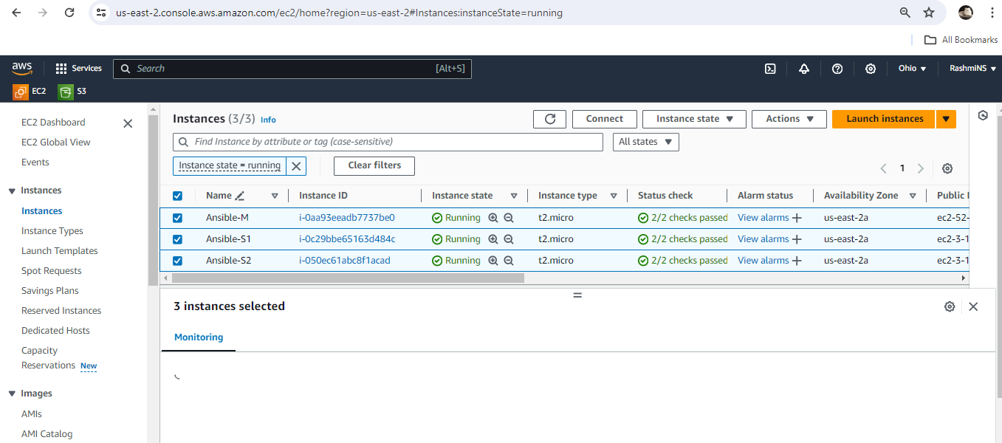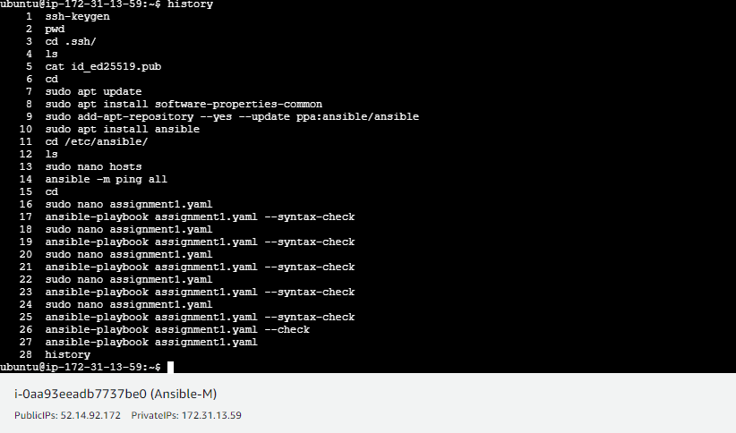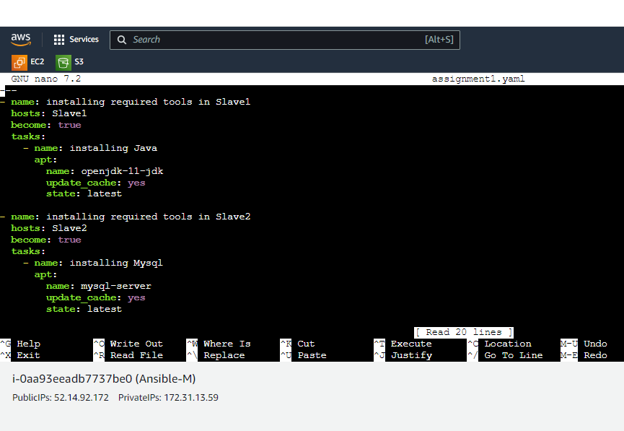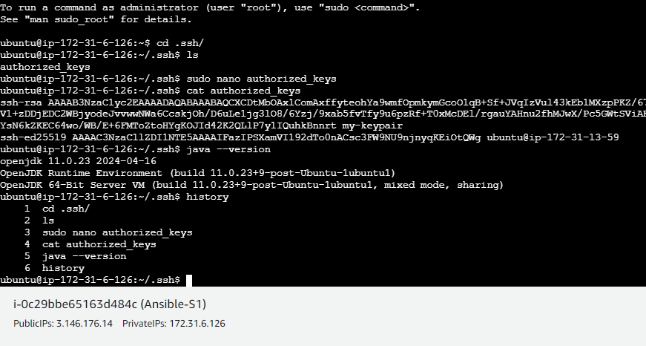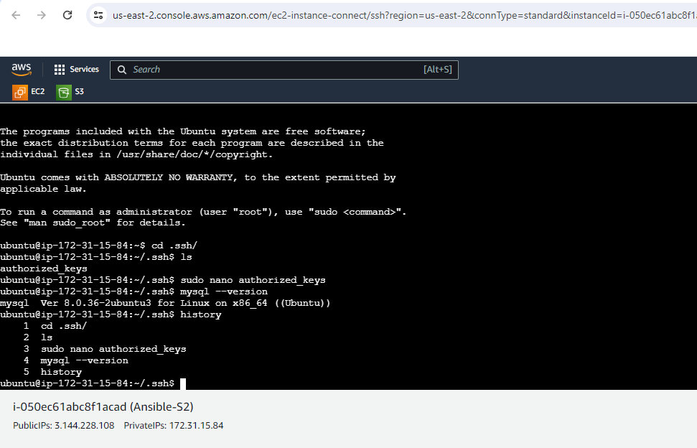

Assignment2: Create a script which can add text “This text has been added by custom script” to

/tmp.1.txt

● Run this script using Ansible on all the hosts

Assignment2 solution:

**In M,

sudo nano assignment2.yaml

---

- name: Creating file in all slaves

hosts: all

become: true

tasks:

- name: running assignment2-script.sh in all slave machines

script: assignment2-script.sh

sudo nano assignment2-script.sh

echo “This text has been added by custom script” > /tmp/1.txt

*In S1 and S2,

cd

cd /tmp/

ls

*In M,

ansible-playbook assignment2.yaml

*In S1 and S2 verify the script file,

ls

cat 1.txt

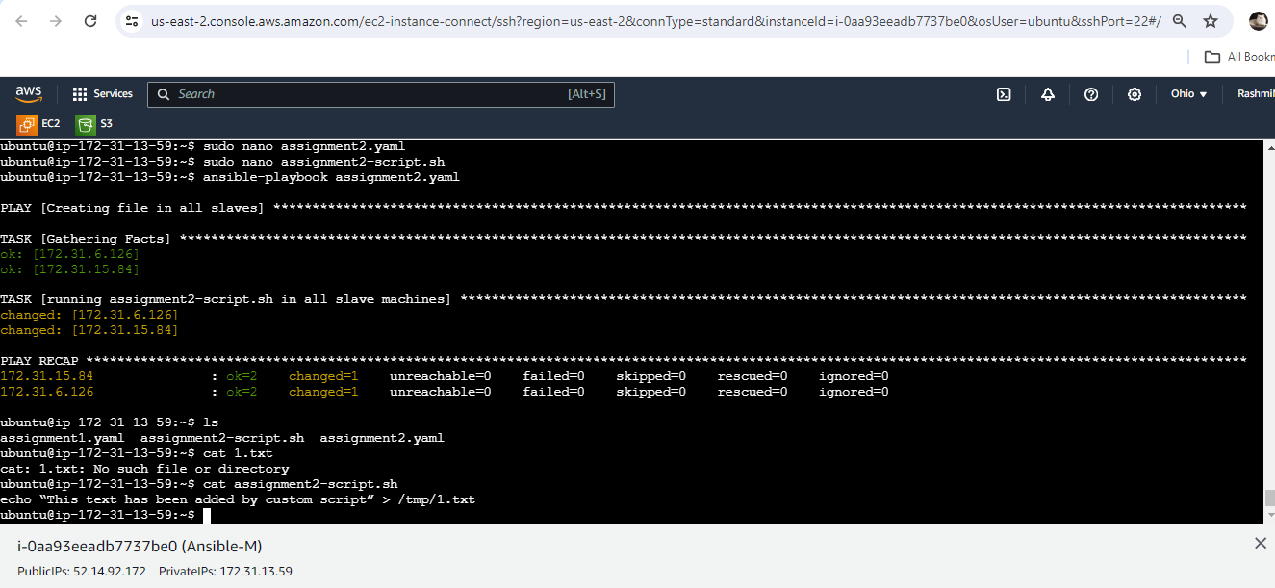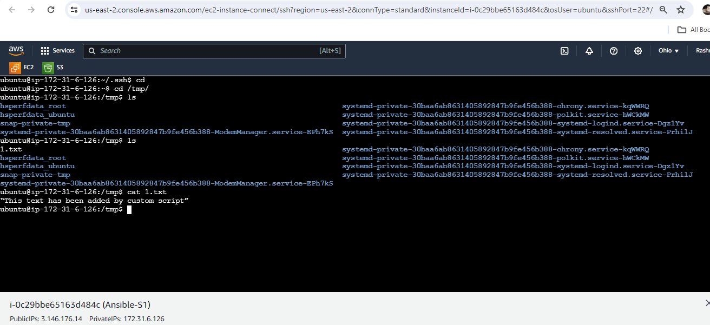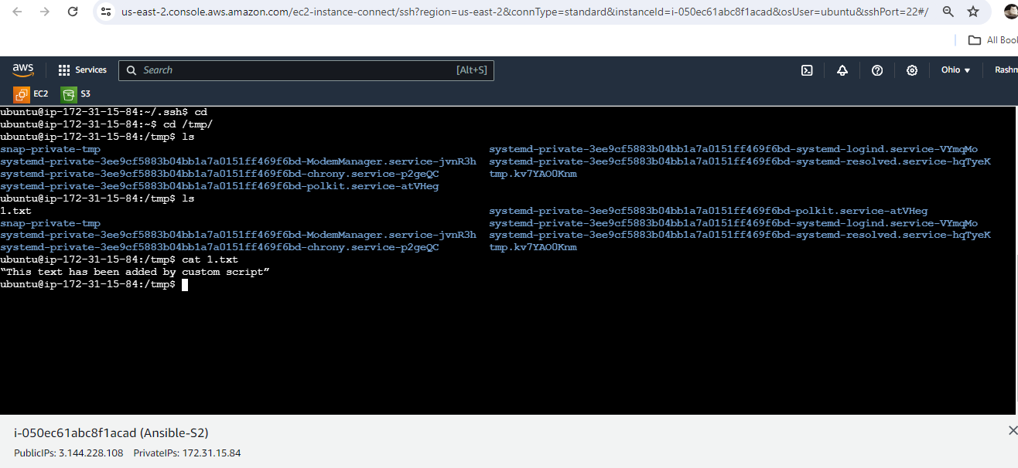

Assignment3: Create 2 Ansible Roles

● Install apache2 on slave1 using one role and nginx on slave2 using the other role

Assignment3 solution:

**In M,

cd /etc/ansible/

ls

sudo ansible-galaxy init apache

ls

cd apache/

ls

cd tasks/

ls

cat main.yaml

sudo nano install-apache.yaml

---

- name: installing apache2

apt: name= apache2 update_cache= yes state= latest

ls

sudo nano main.yaml

---

- include_tasks: install-apache.yaml

cd ../..

ls

sudo ansible-galaxy init nginx

cd nginx/tasks/

ls

sudo nano install-nginx.yaml

---

- name: installing nginx

apt: name= nginx update_cache= yes state=latest

sudo nano main.yaml

---

- include_tasks: install-nginx.yaml

cd

sudo nano assignment3.yaml

---

- name: installing required tools in Slave1

hosts: Slave1

become: true

roles:

- apache

- name: installing required tools in Slave2

hosts: Slave2

become: true

roles:

- nginx

ansible-playbook assignment3.yaml --syntax-check

ansible-playbook assignment3.yaml --check

ansible-playbook assignment3.yaml

**Verify using public IP address of S1 and S2

Assignment4: Use the previous deployment of ansible cluster

● Configure the files folder in the role with index.html which should be replaced

with the original index.html

Assignment4 solution:

*In M,

cd/etc/ansible/roles/nginx/files/

sudo nano index.html

This is a custom html file

pwd

cd ..

cd tasks/

ls

sudo nano replace.yaml

---

- name: replacing original index.html with custom one

copy: src= /etc/ansible/roles/nginx/files/index.html dest=/var/www/html/

ls

sudo nano main.yaml

---

- include_tasks: install-nginx.yaml

- include_tasks: replace.yaml

ls

cd

ansible-playbook assignment3.yaml

Assignment5: Create a new deployment of ansible cluster of 5 nodes

● Label 2 nodes as test and other 2 as prod

● Install java on test nodes

● Install mysql-server on prod nodes

Assignment5 solution:

**Create 2 more new ec2 instances: S3 and S4

*In M,

sudo cat .ssh/id_rsa.pub

>>>Copy the content

*In S3 and S4 terminals,

sudo nano .ssh/authorized_keys

>>>Paste copied content here

*In M,

sudo nano /etc/ansible/hosts

….

….

[test]

____ >>>private Ip of S2

____>>>private Ip of S4

[prod]

____ >>>private Ip of S1

____>>>private Ip of S3

In M,

cat assignment1.yaml

cd /etc/ansible/roles/

ls

sudo ansible-galaxy init java

sudo ansible-galaxy init sql

ls

cd java/tasks/

ls

sudo nano install.yaml

---

- name: installing java

apt: name= openjdk-11-jdk update_cache= yes state= latest

sudo nano main.yaml

---

- include_tasks: install.yaml

cd ../..

cd sql/tasks/

sudo nano install.yaml

---

- name: install sql

apt: name= mysql-server update_cache= yes state= latest

sudo nano main.yaml

---

- include_tasks: install.yaml

cd

cat assignment3.yaml

sudo nano assignment5.yaml

---

- name: installing required tools in S3

hosts: test

become: true

roles:

- java

- name: installing required tools in S4

hosts: prod

become: true

roles:

- sql

ansible –m ping all

>>>yes

>>>yes

ansible-playbook assignment5.yaml

**Verify in all the Slave machines:

In S1 and S4:

java --version

In S3 and S2:

mysql –version

**In M,

cat /etc/ansible/hosts